**Memory awareness fund**

**Micro Grants Scheme**

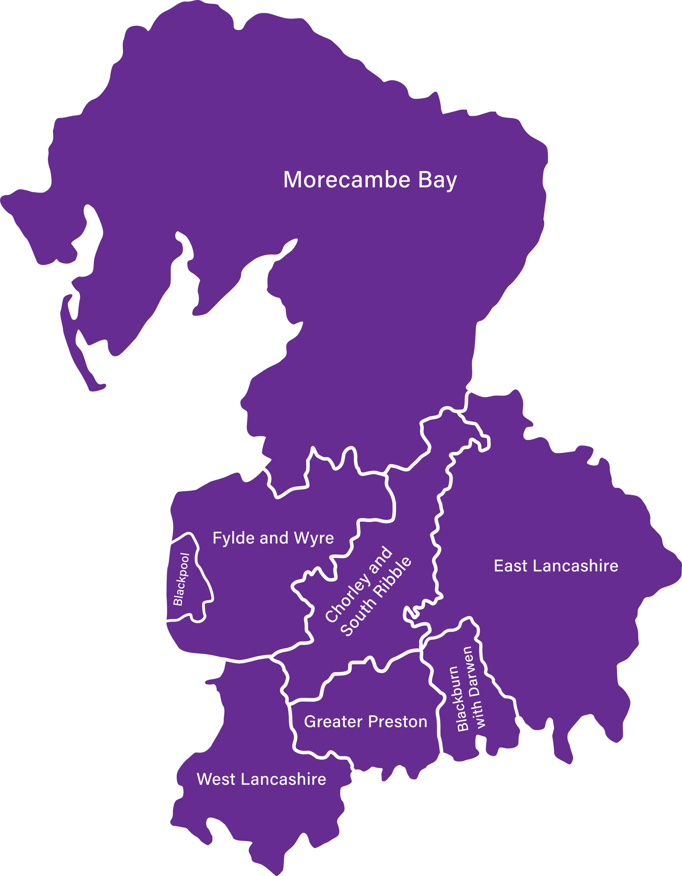



**Who are LBN?**

About Inclusive North

Inclusive North previously known as Lancashire BME Network (LBN) was established in 1996 as an infrastructure-plus organisation. Inclusive North exists to understand and address the inequalities and systematic marginalisation and discrimination of racially minoritised communities in Lancashire.

Inclusive North support the development and growth of dynamic, independent, and strong racially minoritised communities and organisations so we can collectively meet the needs of the communities we serve. Inclusive North engages in critical and strategic dialogue with mainstream institutions so that we can work towards more anti-racist structures and processes and racially just funding and commissioning systems.

Our work is a combination of infrastructure support, project delivery and includes research and development and consultancy services. Inclusive North works closely with private and public sector bodies and organisations for example: Prisons, Universities, Housing Associations and Healthcare providers.

For more information:

|  |  |  |  |  |  |  |  |  |
| --- | --- | --- | --- | --- | --- | --- | --- | --- |
| |  |  |  |  |  |  |  |  | | --- | --- | --- | --- | --- | --- | --- | --- | | |  | | --- | | [Facebook](https://eur01.safelinks.protection.outlook.com/?url=https%3A%2F%2Fwww.facebook.com%2FLancsBME%2F&data=05%7C02%7CMaryam.Khan%40lancashirebmenetwork.org.uk%7Ccbf74d22e7494117675d08dc36dacfd1%7C7f5d06609a974b52866b8a2983ead620%7C0%7C0%7C638445560643173958%7CUnknown%7CTWFpbGZsb3d8eyJWIjoiMC4wLjAwMDAiLCJQIjoiV2luMzIiLCJBTiI6Ik1haWwiLCJXVCI6Mn0%3D%7C0%7C%7C%7C&sdata=6T3kn0h5VhEhRoGx69EovF7BdmAwTDM2QlxbC1K%2FZcE%3D&reserved=0) | | |  | | --- | | [X](https://eur01.safelinks.protection.outlook.com/?url=https%3A%2F%2Ftwitter.com%2FLBN_Lancashire&data=05%7C02%7CMaryam.Khan%40lancashirebmenetwork.org.uk%7Ccbf74d22e7494117675d08dc36dacfd1%7C7f5d06609a974b52866b8a2983ead620%7C0%7C0%7C638445560643179529%7CUnknown%7CTWFpbGZsb3d8eyJWIjoiMC4wLjAwMDAiLCJQIjoiV2luMzIiLCJBTiI6Ik1haWwiLCJXVCI6Mn0%3D%7C0%7C%7C%7C&sdata=pT2AgSIHAFi5ZQHJsiIdDGv%2BWNtUAd%2FR6qMn5c15zP4%3D&reserved=0) | | |  | | --- | |  | | |  | | --- | | [YouTube](https://eur01.safelinks.protection.outlook.com/?url=https%3A%2F%2Fwww.youtube.com%2Fchannel%2FUC7SEnIuhVRjMdOOhEVv__Gw&data=05%7C02%7CMaryam.Khan%40lancashirebmenetwork.org.uk%7Ccbf74d22e7494117675d08dc36dacfd1%7C7f5d06609a974b52866b8a2983ead620%7C0%7C0%7C638445560643191388%7CUnknown%7CTWFpbGZsb3d8eyJWIjoiMC4wLjAwMDAiLCJQIjoiV2luMzIiLCJBTiI6Ik1haWwiLCJXVCI6Mn0%3D%7C0%7C%7C%7C&sdata=d95aTkCsUKr2UI2LRAPTOErPyELOcwviS5ef2iwWTJ4%3D&reserved=0) | | |

Website: [Lancashire BME Network | Equality | Diversity | Inclusion](https://lancashirebmenetwork.org.uk/)

**The funds can be used for:**

Supporting or helping vulnerable people with memory loss issues and can include the following:

* Wellbeing Services.
* Work with groups of people experiencing memory loss, Dementia, Alzheimer’s.
* Work that reduces social isolation.
* Dementia friendly Activities: one-off equipment, sporting goods, walking boots, initial help with transport costs.

**Criteria for all organisations:**

Applicants must meet the following criteria to be eligible for the funding:

* The application must be for the benefit of people affected by dementia who are residing within the geographical boundaries of Lancashire.
* The project must be dementia friendly and inclusive.
* The applicant must provide evidence of project expenditure and beneficiary involvement as required by the funder.
* The lead person is to provide a final report (template will be provided)

**Applications,** where possible, will be considered within eight weeks of receipt.

We will request for bank details on the application form.

**Who can apply?**

**Any VCFS, voluntary, community, organisation, groups can apply providing they are:**

* Groups/Organisations operating in Lancashire area.
* Supporting individuals that help/support people with memory loss.

**We are not a registered charity; can we still apply?**

* Yes, you can still apply. You can be unregistered, a CIC, a group of volunteers that support the community. If you are unsure, please get in touch.

**Who cannot apply?**

* If your activity/support lies outside of Lancashire area.
* For political/religious purposes (including religious festivals and practice).
* If you have been part funded/fully funded in the previous round, you are not eligible to make any further grant applications.

**Can I apply for the Micro Grant Scheme up to £1,000?**

* **Grant amount: The maximum that you can apply for is £1,000.**

**How long before I know that my application has been successful?**

* Once the deadline has passed, the panel will meet to decide which projects they would like to fund. This will take up to 15 working days following the closing date.
* If you receive a conditional offer in writing, you will have 10 working days to respond, or the application will be withdrawn.

**Do I need a bank account in my organisation/group name?**

* Yes, if you are applying on behalf of an organisation then the bank account must be held in the organisations name with two unrelated signatories.
* If you are applying as an individual the bank account must be in the name of the applicant.

**How long do I have to spend the funds?**

* You MUST have spent the funds by the end of **August 2024**.

**Will I have to send reports about what I have spent the money on?**

* We will be asking you for a mini report, a template of which will be sent out once you have been successful. In addition, you can provide photographic, video, or case studies/testimonial and evidence of spend.

**What evidence do I need to keep?**

* Keep any financial evidence/records.

**Individuals applying need to provide the following information:**

* Beneficiary Details
* Evidence of the beneficiary diagnosis of memory issues
* Verbal/Written consent.

**What if I cannot fill in the application form?**

* Please contact us via email on: [grants@lancashirebmenetwork.org.uk](mailto:grants@lancashirebmenetwork.org.uk)

**If you are unsure whether you are eligible, please contact us via phone/email on 01254 392974/**[grants@lancashirebmenetwork.org.uk](mailto:grants@lancashirebmenetwork.org.uk)

**How to apply:**

1. You must complete the application form.
2. Fill in the application form, which is in Word format, and email it to us as an attachment.
3. We can also arrange a Zoom/Teams meeting, telephone interview or in person meeting to support with the writing of an application - please contact us if this is needed.

**The Grant Schemes:**

The **‘Micro Grant’** consists of grants **up to £1,000.**

Projects need to be delivered by the end of **August 2024.**

If this will be a problem, please contact a member of our team.

**The Application Process**

The application contains four sections that **must** be completed for the application to be considered.

**Section 1:**

About your organisation

Please provide information regarding your organisation information

**Section 2:**

1. Type of organisation

Please tick the box that best describes the type of organisation and provide your charity/company number.

1. Which geographical area will you be covering through this project?

The application must be in the area listed below:

* Lancashire

1. What is your application for?

Please provide information regarding your project/proposal. This can include information about the group / people you wish to support and what they need.

1. What is the total amount of funding you’re applying for?

Please provide a figure of the total amount requested.

**Maximum amount you can request is £1,000.**

1. Breakdown of cost of your project?

Please provide a breakdown of costs, this can include project, volunteer, or costs for goods / services (e.g. venue hire)

**Section 3:**

1. How have you identified your activity?

For example: attended a similar activity on the Fylde Coast and wanted to replicate it here; research from speaking with people living with dementia locally.

1. How will you / your proposal meet the individuals needs and aspirations of a person/people with dementia?

How would your proposal help someone learn a new skill or support an existing hobby or interest. Would it help support the well-being of a person/people with dementia and their careers. Or would it help a person/people with dementia living in rural areas where there are no similar services?

1. Please say who/how many people will benefitting from this project?

How many people can join in with your project, do you want to target certain people E.g. younger people with dementia, how many people do you anticipate will benefit from the project.

1. We would love to learn more what you’re planning or already providing. Is there anything else you’d like to add?

Please tell us anything you think might support your application or be useful for us to know in our roles supporting the community. Feel free to send an email or additional sheets if necessary.

**Section 5:**

Bank Details

Ensure to complete this section to speed up the process, as if you are successful, we will notify you and the process of providing you with funding becomes faster. If you do not have a bank account, then we cannot accept your application.